**Pool in wharfedale neighbourhood plaN – Consultation on proposed changes**

**January 13th-February 10th 2025**

This schedule sets out specific changes proposed to the Pool in Wharfedale Neighbourhood Plan. In response to Examination Note 2 from the Examiner, a consultation on the proposed changes with the residents of Pool-in-Wharfedale is being undertaken.

This consultation does not concern matters not discussed in this document, and any previous representations made on those other matters will be ‘carried forward’ and considered by the Examiner for the purpose of any further, less substantial modifications in the final Examiner’s Report.

You can respond to this consultation at [**surveys.leeds.gov.uk/s/PIWReg17/**](https://surveys.leeds.gov.uk/s/PIWReg17/)

In terms of presentation, new inserted text is denoted as **bold underline.**

**Comments are to be submitted by Monday 10th February 2025 (5pm).**

| **No** | **Existing** | **Proposed Changes** | **Reason** |
| --- | --- | --- | --- |
| **1** | Renaming of Special Landscape Areas to Areas of Local Landscape Sensitivity (boundaries to remain as existing). Existing text:  **Otley Chevin and Wharfe Valley Southern Slopes Special Landscape Areas**  The Pool-in-Wharfedale Neighbourhood Area is located within a rich rural landscape. Proximity and ready access to open and varied countryside, with the River Wharfe along its northern boundary, the high ground of the Chevin and Pool Bank to the south and farmland between is one of the characteristics which define it. This accessible green environment is something which the community is anxious to preserve, a fact clearly expressed in consultations to date which highlight the importance of agricultural and recreational land. In the 2017 Policy Intentions Document consultation, over 94% of respondents supported a policy to control development within Special Landscape Areas, with over 85% of respondents to the 2019 consultation endorsing the resultant proposed policy.  The importance of this landscape has been recognised by Leeds City Council, with much of it covered by two ‘Special Landscape Area’ (SLA) designations (Otley Chevin and Wharfe Valley Southern Slopes - see The Neighbourhood Plan Map) in the saved policies of the Unitary Development Plan (UDP). As a result, their character and appearance both enjoy protection against unsympathetic development. These areas are also designated as Green Belt and, for the most part, Strategic Green Infrastructure in the Council’s Core Strategy, affording protection which this plan cannot strengthen. Information from the UDP, based on the 1994 Landscape Assessment produced by Leeds City Council and The Countryside Commission, does however provide more detailed information on the localised character of these landscapes and a basis for a more nuanced Neighbourhood Plan policy in respect of new development.  **Otley Chevin**  Extending westwards from Pool-in-Wharfedale and Bramhope (outside the Neighbourhood Area), this part of the SLA occupies the southern slopes of the Wharfe Valley and affords fine views across the valley to Nidderdale, Farnley Moor and Leathley Moor. The steepest slopes, including the Chevin Forest Park, are heavily wooded and include unique rock formations. The remainder consists mainly of a fairly intact field pattern with walls or hedges and mature trees. Scattered farmsteads and houses occupy the north-facing slopes north of the Chevin woodlands and the A660, south of the disused railway line.  **Wharfe Valley Southern Slopes**  This area occupies the southern escarpment slopes of the Wharfe Valley and the valley floor down to the river, extending from Pool-in-Wharfedale eastwards to Collingham (outside the Neighbourhood Area). It is characterised by the flat but well-treed arable land south of the river ascending to the steep north-facing escarpment slopes with scattered woodlands, largely beyond the Neighbourhood Area boundary. There are fine long distance views across the valley from many lanes and other viewpoints. The Harrogate-Leeds railway viaduct north of Bramhope and the wooded outlier of Rawden Hill near Weardley are attractive elements in many views.  **POLICY GE1: OTLEY CHEVIN AND WHARFE VALLEY SOUTHERN SLOPES SPECIAL LANDSCAPE AREAS**  In the designated Special Landscape Areas, as shown on The Neighbourhood Plan Map, development will be supported, provided it would not seriously harm the character and appearance of the landscape.  In terms of siting, design and materials, development or change in land use must demonstrate regard to the area’s landscape character and special features and contribute positively to landscape restoration or enhancement, paying particular attention to its:  I. Strong structure and visual unity;  ii. interesting topography;  iii. high scenic quality and fine views;  iv. local rarity, e.g. in its rock formations;  v. groups of buildings that make a positive contribution to  local distinctive character;  vi. landmarks;  vii. natural and semi-natural woods, trees and hedgerows. | **Policy GE1 to designate a new Area of Local Landscape Sensitivity with new supporting text**  **POLICY GE1: OTLEY CHEVIN AND WHARFE VALLEY SOUTHERN SLOPES** **AREA OF LOCAL LANDSCAPE SENSITIVITY**  In the designated **Area of Local Landscape Sensitivity,** as shown on the Neighbourhood Plan Map, development will be supported, provided it would not seriously harm the character and appearance of the landscape.  In terms of siting, design and materials, development or change in land use must demonstrate regard to the area’s landscape character and special features and contribute positively to landscape restoration or enhancement, paying particular attention to its:  i. strong structure and visual unity;  ii. interesting topography;  iii. high scenic quality and fine views;  iv. local rarity, e.g. in its rock formations;  v. groups of buildings that make a positive contribution to local distinctive character;  vi. landmarks; **and**  vii. natural and semi-natural woods, trees and hedgerows.”  **New supporting text:**  **“Recognising the importance of the two areas currently designated as Special Landscape Areas, a new Area of Local Landscape Sensitivity is designated in the Neighbourhood Plan. This area follows the same boundaries as they apply to the Neighbourhood Plan area as the Special Landscape Areas originally designated in the UDP. The designation does not preclude any development taking place in the area, but it does mean that proposals will need to be designed to be in harmony with, and respect, the landscape character and special qualities of the area.** | To ensure that the status of the designation remains beyond the Local Plan Special Landscape Areas designation. |
| **2** | Existing policy text TT1 and policy TT3 to be superseded:  **Current:** POLICY TT1: IMPROVED WALKING AND CYCLING PROVISION  Development directly affecting the Pool-in-Wharfedale footpath and cycleway network, as shown on the Neighbourhood Plan Map, will be expected to be compatible with it and contribute to improvements of it.  Development likely to increase pedestrian footfall and/or cycle usage within the network will be expected to contribute to improvements or new desired provision in their immediate vicinity and to provide connections to the network.  Development which would add to and/or improve the cycleway and footpath network will be supported.  Development which would prevent or harm the development of Wharfedale Greenway along the identified route, as shown on the Neighbourhood Plan Map, or of designated access routes to the Greenway, will not be supported.  **Delete policy TT3:**  **Current:** POLICY TT3: POOL-IN-WHARFEDALE RAIL LINK REINSTATEMENT  Development which would prevent the reinstatement of a Pool-in-Wharfedale rail or tram link, along the line of the former railway as shown on the Neighbourhood Plan Map or prejudice the associated provision of a Pool-in-Wharfedale railway station to service the link, will be resisted. | **Revised proposed policy amendments (merging of policy TT1 and TT3 to be superseded by the following)**  POLICY TT1: **SUSTAINABLE TRANSPORT MODES:** IMPROVED WALKING, CYCLING, **WHEELING AND RIDING** PROVISION **AND LONG TERM RAILWAY REINSTATEMENT**  Development directly affecting the Pool-in-Wharfedale footpath**, bridleway** and cycleway network, as shown on the Neighbourhood Plan Map, will be expected to be compatible with it and contribute to improvements of it.  Development likely to increase pedestrian footfall and/or cycle usage within the network will be expected to contribute to improvements or new desired provision in their immediate vicinity and to provide connections to the existing network.  **Otherwise acceptable** development which would add to and/or improve the cycleway, **bridleway,** and footpath network**, while maintaining the historic railway line,** will be supported.  Development which would prevent or harm:  1. the Wharfedale Greenway along the identified route, as shown on the Neighbourhood Plan Map;  2. designated access routes to the Greenway; or;  **3. the historic railway line and its potential future reinstatement;** will not be supported.  **Development which supports the long term aspiration to reinstate the historic Railway line as a train or tram route without prejudicing the active travel function of the route will be supported.** | The combined policy is designed to make the intent of previous TT1 and TT3 clearer. To ensure the prioritisation of the walking and cycling provision while also supporting reinstatement of the railway line if it does not prejudice this. |
| **3** | **POLICY CFS3: LAND EAST OF MAIN STREET**  Land East of Main Street, as shown on the Neighbourhood Plan Map, presents an opportunity for the development of community uses, which could include any of expanded or new village retail, parish council offices and cultural uses (such as a parish museum/archive), together with associated public car parking.  Any development of this site should have regard to the following:  i. preservation or enhancement of the character or appearance of the Pool-in-Wharfedale Conservation Area within which the site is located;  ii. preservation of the settings of listed and positive buildings adjacent and opposite to the site;  iii. the carrying out of a traffic impact assessment of the development;  iv. provision of electric vehicle charging infrastructure in parking spaces to at least the minimum standard of provision either recommended or required. | It is proposed policy CFS3 to be deleted from the neighbourhood plan. | It is unlikely that the land will become available over the lifetime of the plan. |
| 4 | Local Green Space – Site Reference LGS01 – Arthington Lane Verges | Local Green Space – Site Reference LGS01 – Arthington Lane Verges | Consequential amendment to reflect policy GE3 and provide further clarity. |
| 5 | Local Green Space – Site Reference LGS5 – Pool Bank Quarries | Local Green Space – Site Reference LGS5 – Pool Bank Quarries | Consequential amendment to reflect policy GE3 and provide further clarity by removing hard surfacing and buildings |
| 6 | Local Green Space – Site Reference LGS6 – Pool in Wharfedale Riverside Park | Local Green Space – Site Reference LGS6 – Pool in Wharfedale Riverside Park | Consequential amendment to reflect policy GE3 and provide further clarity by removing hard surfacing and buildings |
| 7 | Local Green Space – Site Reference LGS7 - Pool in Wharfedale Church of England Primary School Grounds | Local Green Space – Site Reference LGS7 - Pool in Wharfedale Church of England Primary School Grounds | Consequential amendment to reflect policy GE3 and provide further clarity by removing hard surfacing and buildings |
| 8 | Local Green Space – Site Reference LGS8 – St Wilfrid’s Churchyard | Local Green Space – Site Reference LGS8 – St Wilfrid’s Churchyard | Consequential amendment to reflect policy GE3 and provide further clarity by removing hard surfacing and buildings |
| 9 | Neighbourhood plan Policies Map | Revised Neighbourhood plan Policies Map | Policies map updated to provide clarity. |

**Appendices**

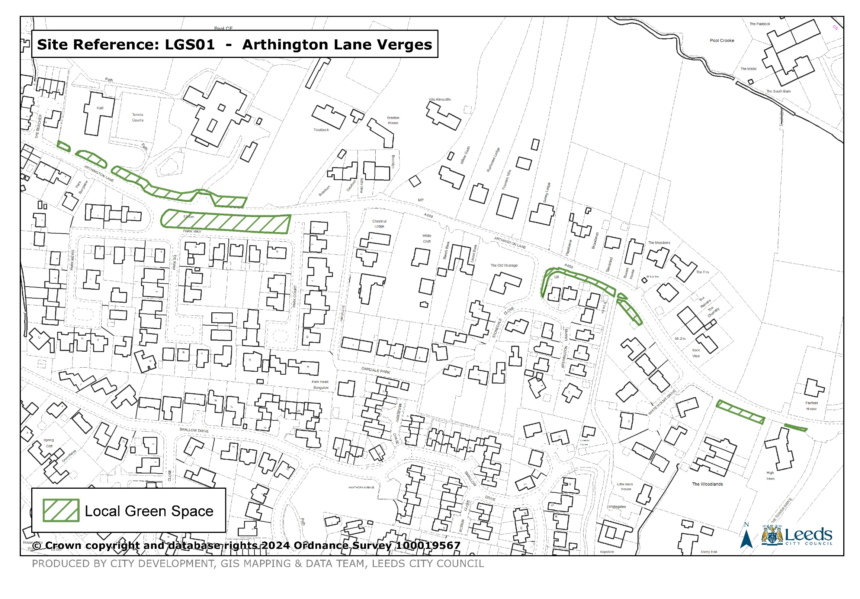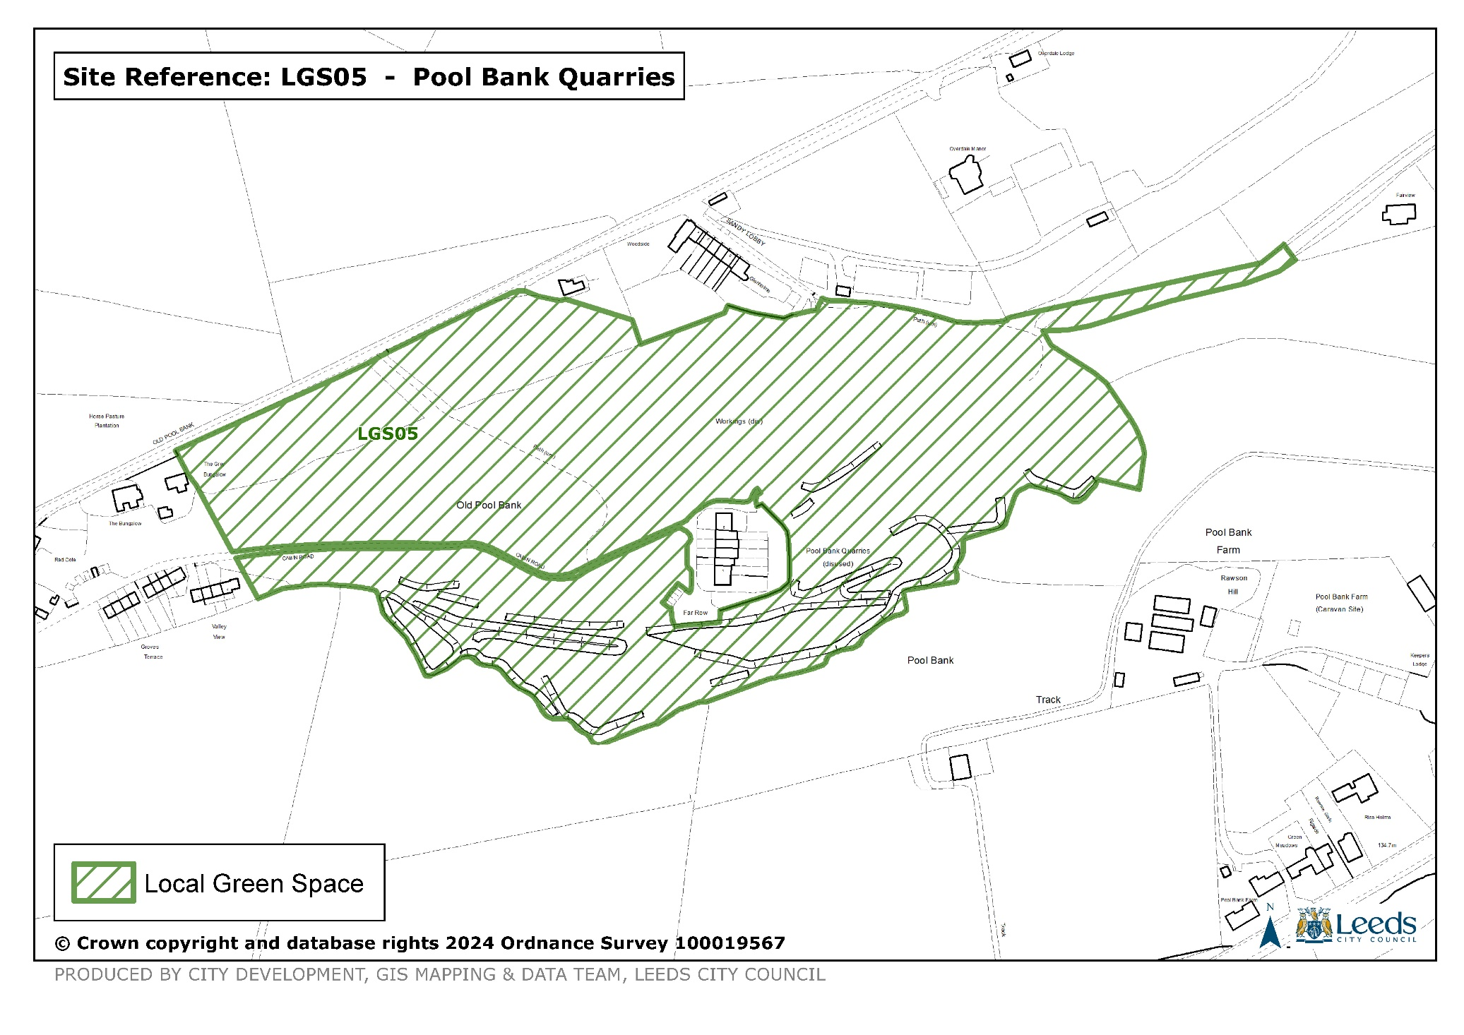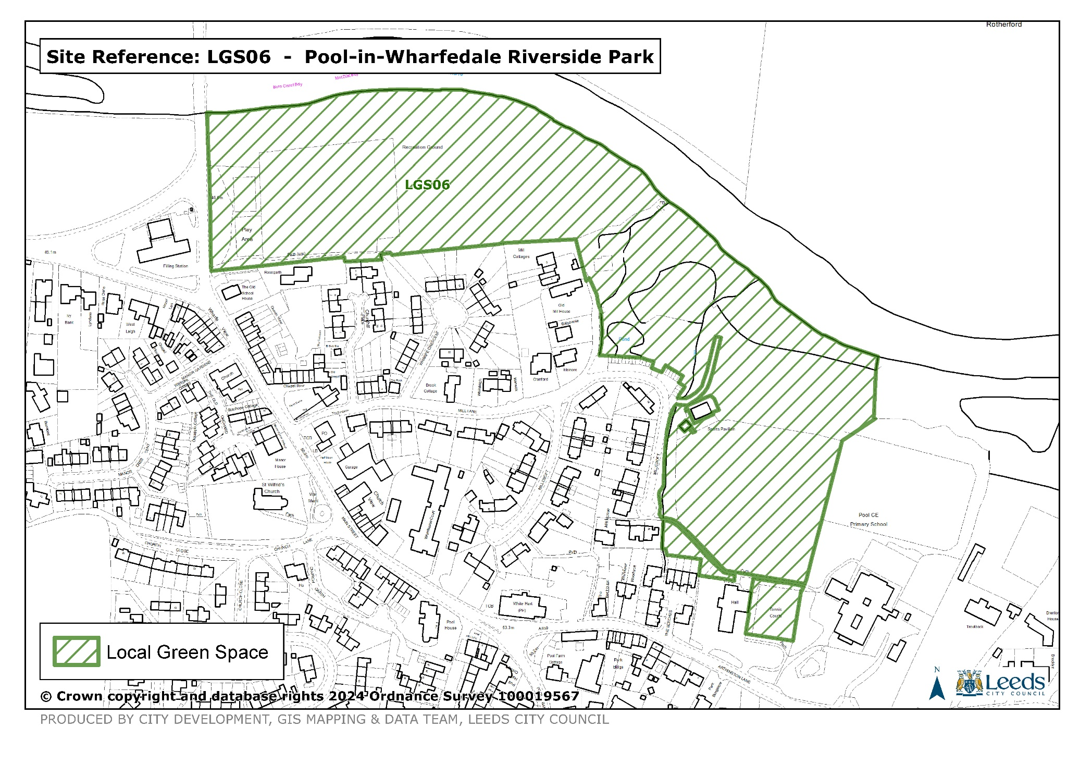

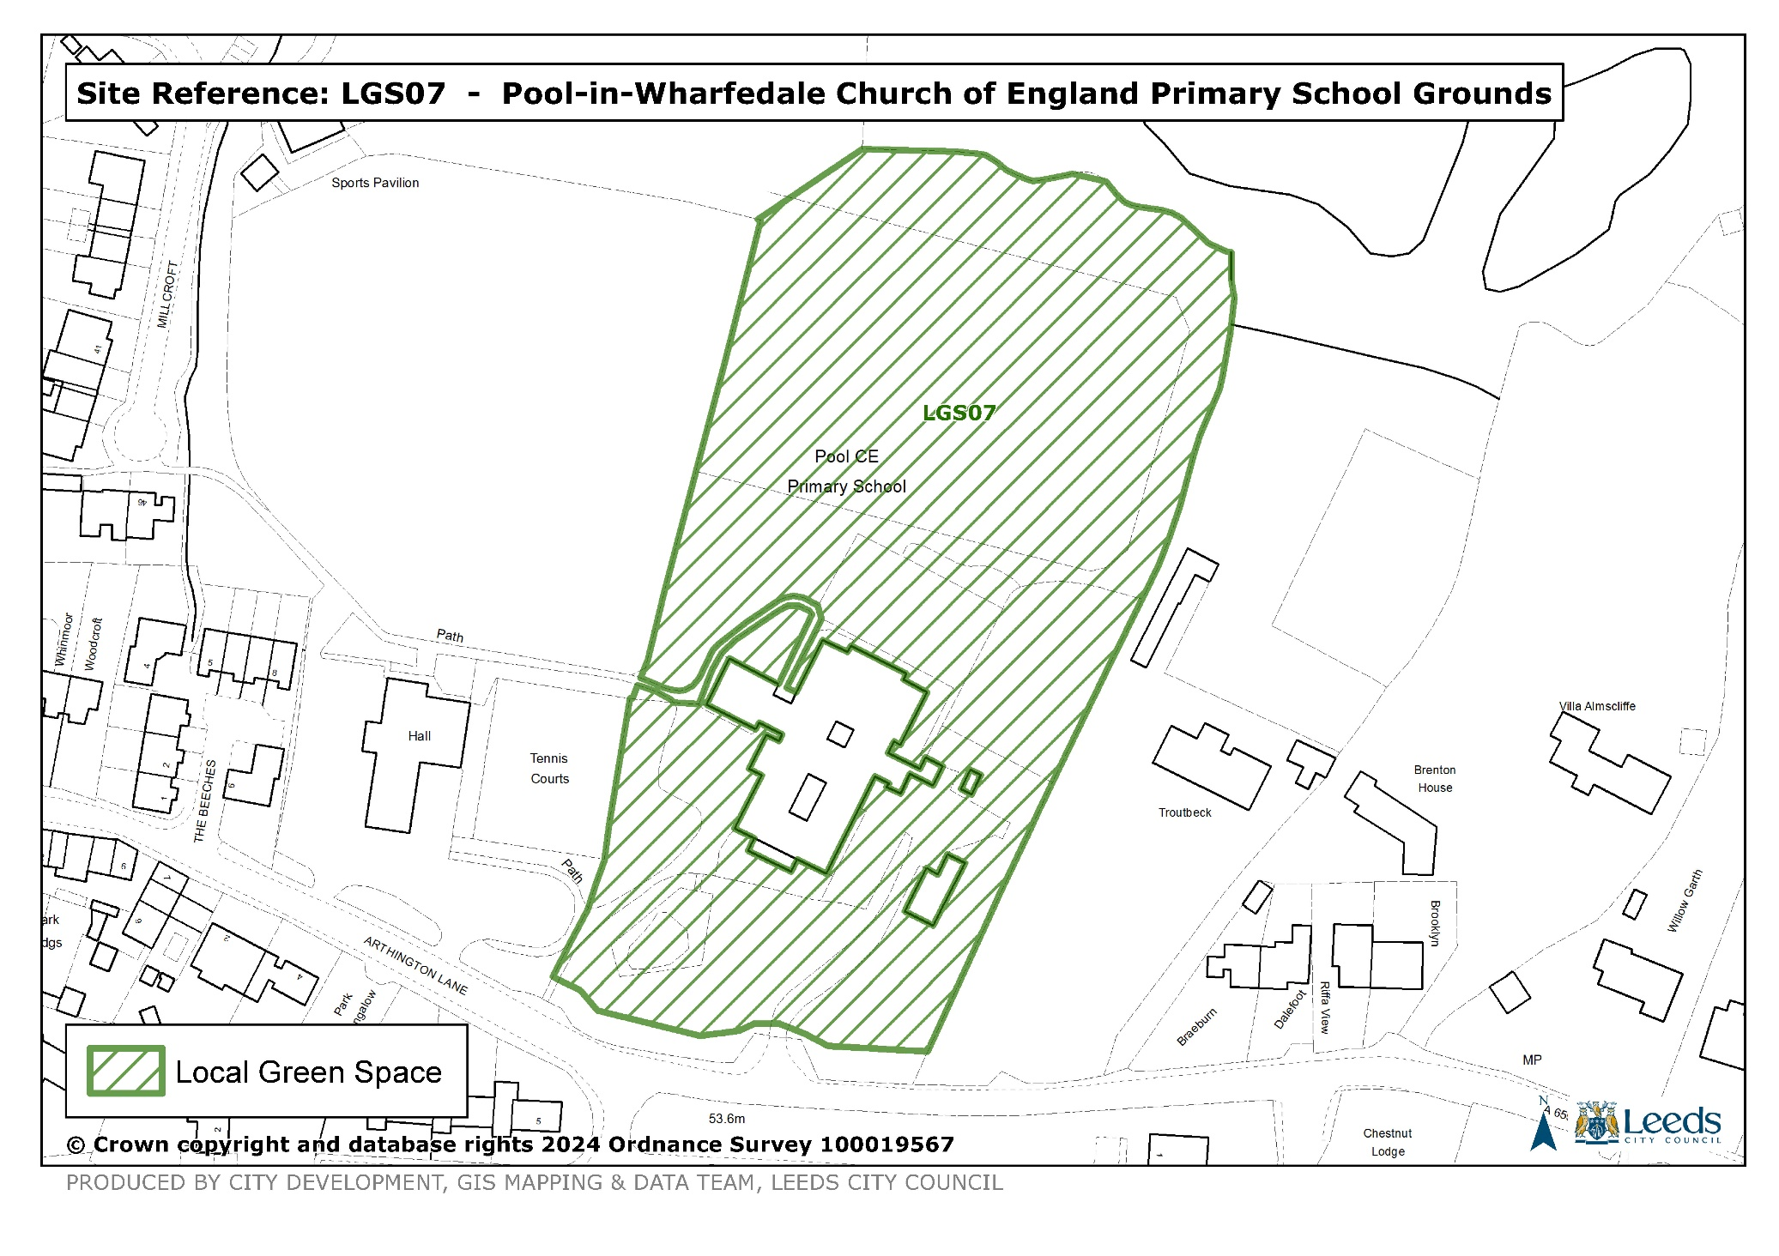

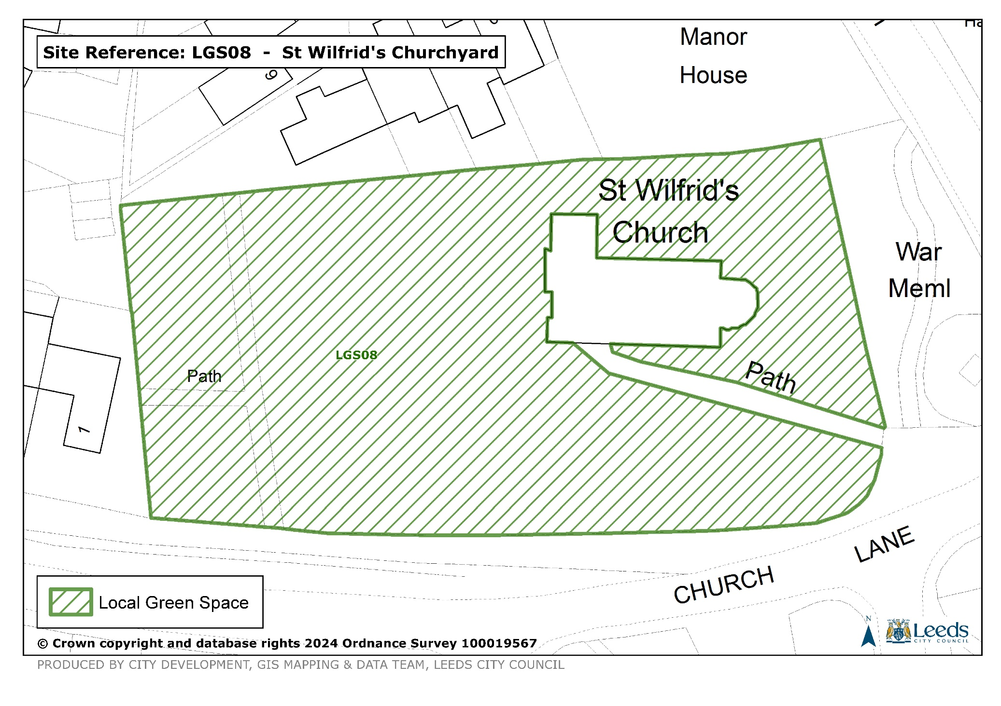A map showing the Neighborhood Plan Policies



Pool in wharfedale neighbourhood plaN – Consultation on proposed changes

January 13th-February 10th 2025