Pool-in-Wharfedale Parish Council

Vacancy for a Councillor

Notice is hereby given that due to the recent death of Richard Parker a vacancy exists in the office of Parish/Town Councillor for the Parish Council of Pool-in-Wharfedale.

The vacancy will be filled by election if any ten local government electors for the said area submit a written request to that effect in the manner prescribed below and if no such request is made the vacancy will be filled by the Parish Council.

Any request for an election to be held to fill the vacancy must be in writing and must reach the Returning Officer, Leeds City Council, Electoral Services, Civic Hall, Calverley Street, Leeds LS1 1UR by no later than the 28th April 2025

Dated: 7 April 2025

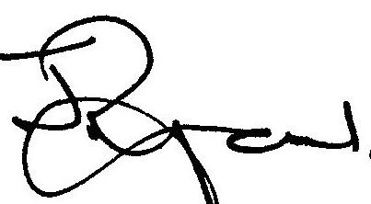

Signed John Ryan Parish Council Clerk

Address 19 Ridgemount Road, Riddlesden, Bradford BD18 4 QT Email: clerk@poolparishcouncil.gov.uk

