

Planning Officer,

Leeds City Council,

Merrion House

Merrion Centre

Leeds

FAO Ian MacKay and Kwame Steadman

11 JUNE 2024

Dear Sirs,

**Submission of Pool-in-Wharfedale Parish Council Neighbourhood Plan**

**Regulation 15 of Neighbourhood Planning Regulations 2012**

At a meeting of the Pool-in-Wharfedale Parish Council of the held on Monday 10th June 2024 it was agreed that the Pool-in-Wharfedale Neighbourhood Plan should be submitted to the Local Planning Authority as required by Regulation 15 of Neighbourhood Planning (General) Regulations 2012.

On behalf of the Pool-in-Wharfedale Parish Council I am therefore submitting the following documents:

Pool-in-Wharfedale Parish Council Neighbourhood Plan

Pool-in-Wharfedale Parish Council Neighbourhood Plan Consultation Statement

Pool-in-Wharfedale Parish Council Neighbourhood Plan Basic Conditions

Pool-in-Wharfedale Neighbourhood Plan SEA & HRA Screening Report 2024

Pool-in-Wharfedale Parish Council Designated Neighbourhood Plan Area

All of which can be accessed via the Pool-in-Wharfedale Parish Council website : Neighbourhood Plan - Pool in Wharfedale Parish Council (www.poolparishcouncil.gov.uk)

Yours faithfully

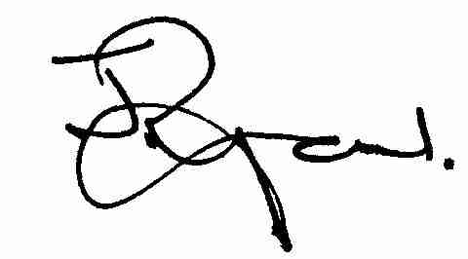

John Ryan

Clerk and Responsible Finance Officer Pool-in-Wharfedale Parish Council.

[clerk@poolparishcouncil.gov.uk](mailto:clerk@poolparishcouncil.gov.uk). 19 Ridgemount Road, Riddlesden, Bradford BD20 5DX. 07766547651